Support Andersen's Success with the DEANS!

Enhance the education at Andersen

Fund cutting-edge
tools and spaces like the Andersen Think Tank and Maker Space, fostering creativity and innovation.

Technology

Community Events

Dolphin Academy Teachers

After-School Programs

Offer activities like Robotics, Chess,

Host events like the Port of July, Pumpkin Patch, and Golf Tournament to bring the Andersen community
together.
t
a
h
W

Hire 3 full-time teachers to provide extra support and challenges for all students. This accounts for 80% of our budget.
o
D
e
W
Basketball, and more, in partnership with Andersen PTA.









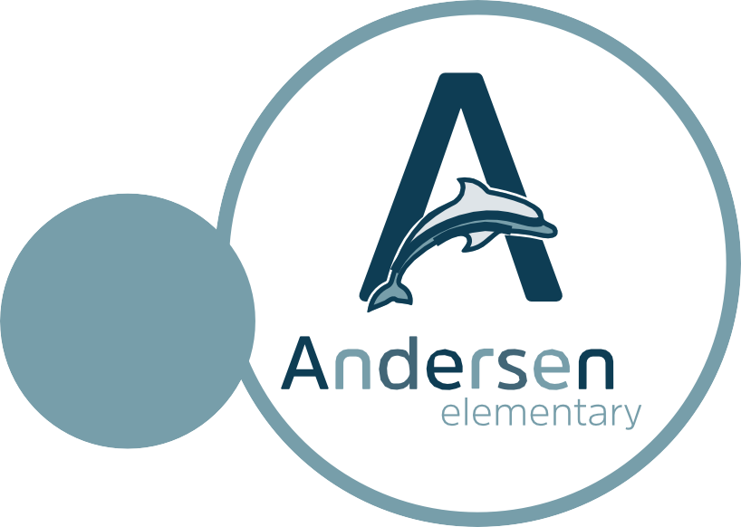



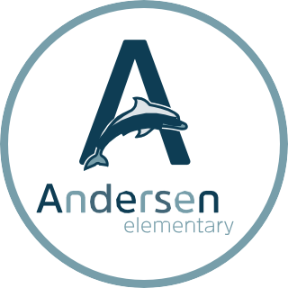


Donate
Support us financially with contributions like the DEANS List ($5,000+ donation).

Volunteer
Help at events and participate in DEANS activities.

Engage
Attend our events and become part of the Andersen family.

Join Us

DEANS Important Dates (subject to change):
August 24, 2023 - DEANS List Party September 7, 2023 - New Parent Orientation Oct 22nd, 2023 - Andersen Pumpkin Patch
March 23rd, 2024 - DEANS Tour de Port Streets April 20th , 2024 - DEANS Dinner Dance
May 13th, 2024 - DEANS Golf Tournament

Contribute Today!
Visit www.andersendeans.org/donate or
text "DEANS List" to 949-325-7079.

